Amazon Sales & Product Performance Dashboard Documentation

1. Dashboard Overview
This dashboard provides a comprehensive overview of Amazon product sales, reviews, discounts, ratings, and revenue performance across different categories.
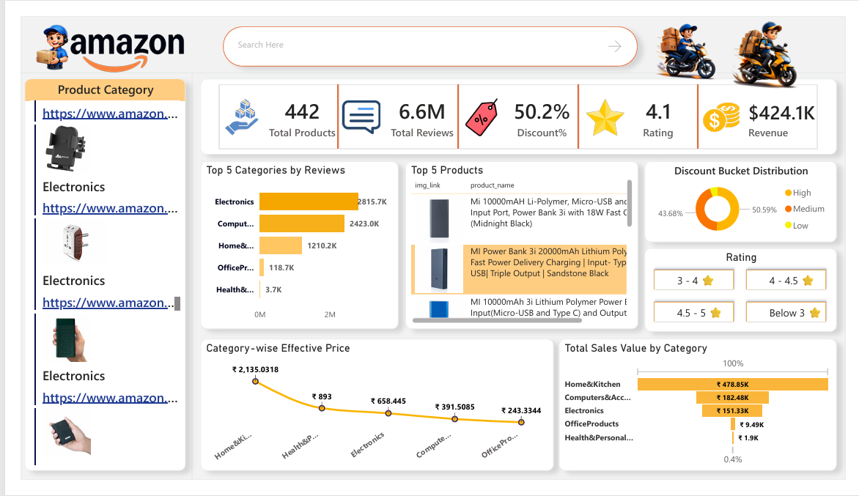

2. Key Performance Indicators (KPIs)
The top section of the dashboard displays the following KPIs:
- Total Products – 442 products available in the dataset.
- Total Reviews – 6.6 Million customer reviews recorded.
- Discount % – 50.2% average discount across products.
- Average Rating – 4.1 overall customer rating.
- Total Revenue – ₹424.1K total revenue generated.

3. Category Analysis
Top 5 Categories by Reviews: Displays categories with highest customer engagement. Electronics and Computers lead in total reviews.
Category-wise Effective Price: Shows the average effective price after discount for each category.
Total Sales Value by Category: Highlights revenue contribution by each category. Home & Kitchen contributes the highest sales value.

4. Product Insights
Top 5 Products section lists best-performing products based on sales/reviews. Includes product image, name, and related performance indicators.

5. Discount & Rating Distribution
Discount Bucket Distribution: Categorizes products into High, Medium, and Low discount ranges.
Rating Distribution: Filters products based on rating ranges (Below 3, 3–4, 4–4.5, 4.5–5 stars).

6. Filters & Navigation
Product Category panel on the left allows users to filter data by category. Search bar enables quick product lookup.

7. Conclusion
This dashboard enables business users to monitor product performance, analyze category trends, track revenue impact of discounts, and make data-driven decisions efficiently.

